HIGHER ORDER DIFFERENTIAL EQUATIONS

Dr. Karl Brommer
E&IS Engineering Fellow and Technical Director, Sensor Systems
603 885 3216
603 772 0486

Agenda
- Introduction and definitions
- First-order differential equations
- Higher-order differential equations
- System applications
- Homework discussion

1. Introduction and Definitions – K1.1

Definition of a differential equation
A differential equation is an equation that involves derivatives of one or more dependent variables with respect to one or more independent variables.

Examples
1. Damped harmonic oscillator with driving term. This is a linear ordinary differential equation from mechanics, electronics and many other applications. Special solution techniques exist.
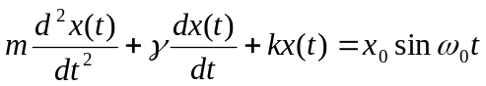
2. Fokker-Plank equation. This is a linear partial differential equation from probability, thermodynamics and elsewhere. While analytic solutions exist for some cases, it is usually solved numerically.

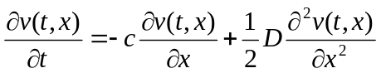
3. Exact pendulum equation. This is a nonlinear ordinary differential equation refining the simple pendulum model you learned in freshman physics. It is solved numerically or as a perturbation on the simple model with sinθ ∼ θ.
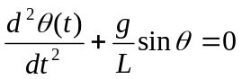
4. Population equation. This is a nonlinear ordinary differential equation used in biology. Solved numerically, it exhibits chaotic behaviour for values of g.
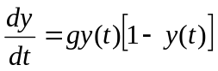

Ordinary differential equations
An ordinary differential equation is an equation involving only ordinary derivatives – no partials. If the dependent variable y=f(x,t), it is possible to solve for y using ordinary derivatives if the equation is separable.

Order of differential equations
The highest order derivative appearing in a differential equation determines its order. All of the previous examples were second order, except the population equation. It was first order.

Degree of differential equations
The highest exponent of any derivative appearing in a differential equation determines its degree. All of the previous examples were first degree. One example of a third degree differential equation is

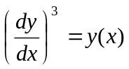

This equation can be solved using integration. More on this later.

Linear differential equations – K1.4
The generic differential equation F(x,y,y’,…,y^{n})=0 is linear if the following conditions hold:

- There are no exponents of derivatives y’,…,y^{n}
- There are no exponents on the dependent variable y.
- There are no products between dependent variables and derivatives.
- There are no products between derivatives.
- There are no transcendental functions of the dependent variable or its derivatives

Examples

Linear
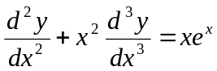

Nonlinear
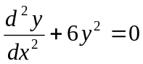

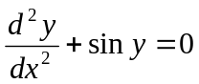

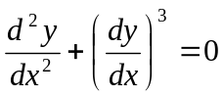

For linear differential equations, the superposition principle holds.

Linear superposition principle
For linear differential equations, the sum of two solutions to the equation is also a solution.
Given.
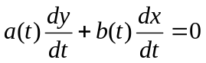 (1)

and solutions {y₁(t),x₁(t)} and {y₂(t),x₂(t)}, then {c₁y₁+ c₂y₂, c₁x₁+ c₂x₂} is also a solution.

Proof

ac₁y’₁+ bc₁x’₁=0 Since {y₁,x₁} are a solution to (1)
ac₂y’₂+ bc₂x’₂=0 Ditto

Now add the two equations

a(c₁y’₁+c₂y’₂)+( bc₁x’₁+bc₂x’₂)=0 Has the same form as (1)

2. First order differential equations – K1.3

Standard form
One common form is a generic first-order ordinary differential equation solved for y’:
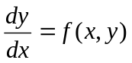 or 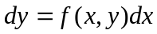
Equations of this form are solved by direct integration.

Example 1
Here’s a very simple example.
= 0
then

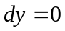
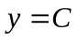
The value of C is determined by posing an initial condition. In this example, y must be constant equal to its initial value. For instance, if y(0)=1, then C=1 and y=1.

Example 2
In this example, the differential equation is a function of the independent variable only. Direct integration produces the solution.
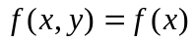
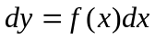
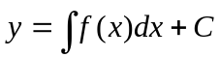
C is determined by the initial condition y(x₀)=y₀.

Example 3
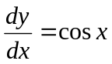, with y(0)=1.
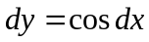
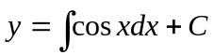
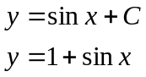
In the last line setting C = 1 satisfies the initial condition y(0)=1.

Example 4
This example is solved by integrating the dependent variable.
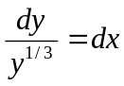

Example 5
This differential equation defines the exponential function. It is common in engineering and physics.
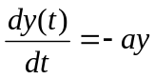 with y(0)=A.
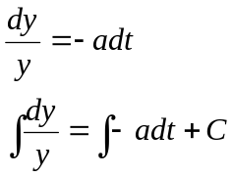
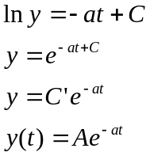
satisfies the initial condition y(0)=A.

3. Higher-Order Differential Equations – K2.1, 2.2

Free Damped Oscillations – K2.4
The equation for a spring or for an RLC circuit is
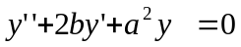
where b and a are positive constants. For a series electrical circuit, 2b=R/L and a²=1/LC and y denotes the voltage across the capacitor. Since this equation is second order with constant coefficients, the trial solution is y=Ae^{st}. Substituting this trial solution into the differential equation gives us the characteristic polynomial s²+2bs+a² with roots s=-b+/-β, where
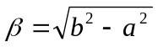
We will discuss the physical significance of the solution in the three cases b>a, b=a and b<a for which b is real and nonzero, or β=0 or β=iω is pure imaginary respectively.

Whenever β is nonzero, the roots are distinct and a general solution is

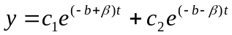
If b>a then b is real and the equation β=b²-a² shows that |β|<b. Hence both of the quantities –(b-β) and –(b+β) in the exponents are negative. This is the overdamped case. The resistance is so great that no oscillation can occur and the solution decays exponentially as t-> infinity.

The constants c₁ and c₂ depend on the initial displacement y₀ and the initial velocity y₁. Setting t=0 in the solution gives
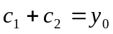
and differentiating and setting t=0 gives
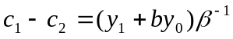
when we use . The value of c₁ is now obtained by adding these equations and c₂ by subtracting them. For example if y₀=0 and y₁=1, the solution is
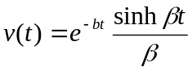
When a=b, the two roots of the characteristic equation are also equal. In this case a general solution is
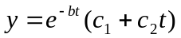 for a=b
This is the critically damped case. Its general character is similar to the overdamped case.

The more interesting case occurs when b<a

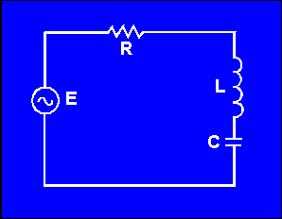
Additional Reading on Free Damped Oscillations: Kreysig Ch 2; also Sokolnikoff and Redheffer 3.1, 3.5, 3.6, 3.8

4. System Applications – K2.9

The components of the circuit above can be described by the following equations:

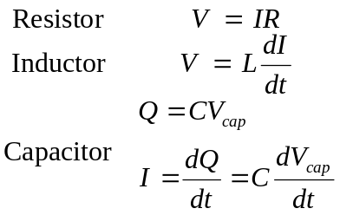 | (1)

Applying Kirchoff’s Voltage Law to the circuit and substituting 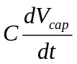for , we can describe the circuit in terms of the voltage across the capacitor, 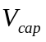.

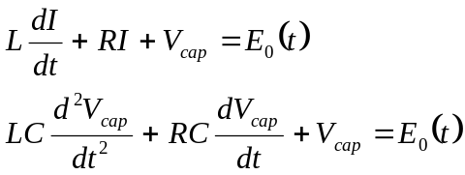 | (2)

This differential equation has the form:

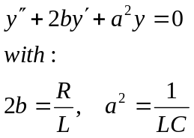 | (3)
Use a trial solution:
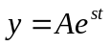 | (4)

The characteristic polynomial is:
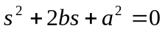 | (5)

We know the roots of a characteristic polynomial are:
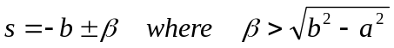 | (6)

We want to analyze three cases:
Overdamped: b > a => β is real, non-zero
Critically damped: b = a => β = 0
Underdamped: b < a => β = jω (pure imaginary)
OVERDAMPED CASE: b > a – K2.4

Β is real with: |β| < b
General solution is:
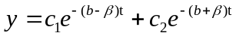 | (7)

Both exponents are negative. This is the overdamped case where no oscillation can occur. Typical curves, dependent on the initial current, are shown in the figure below.

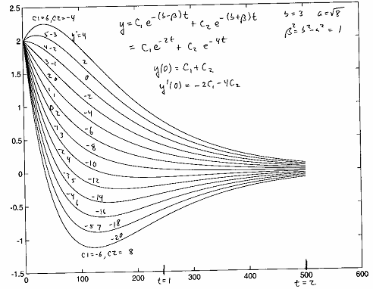
The constants and 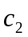depend on the initial voltage 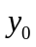and the initial current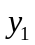.
Setting 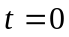in (7) gives:
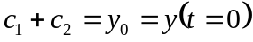 | (8)

Differentiating and setting in (7) gives:
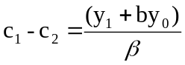 | (9)

Proof:
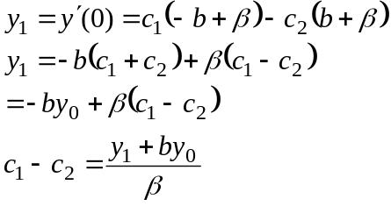 | (10)

You can find from 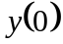, 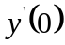by adding:
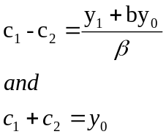 | (11)

You can find by subtracting the same equations.

CRITICALLY DAMPED CASE: a = b
The general solution is:
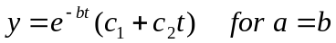 | (12)

It is characteristically similar to the overdamped case:
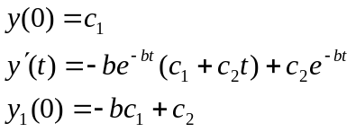 | (13)

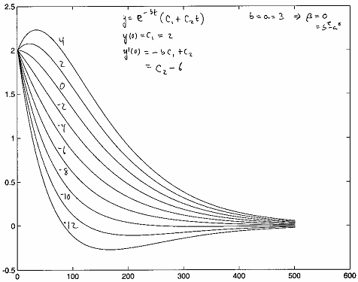
UNDERDAMPED CASE: b < a
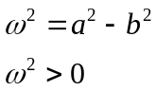 | (14)

Now define: 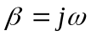
General solution is:
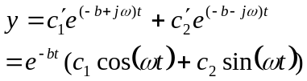 | (15)

Initial conditions:
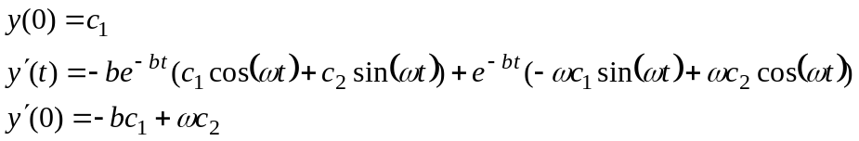 | (16)

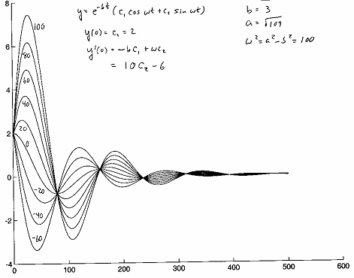

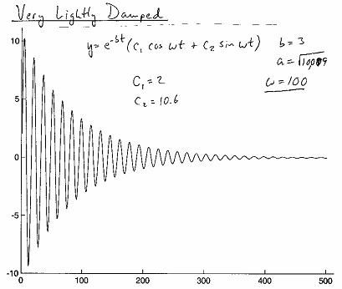

NON-HOMOGENEOUS EQUATIONS – K2.7, 2.8
The equation 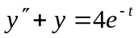 is non-homogeneous because the right hand side ≠ 0.
The function, 2e^{-t}, is a solution because substitution reduces to an identity in ‘t’. It is called the particular solution. The general solution is:
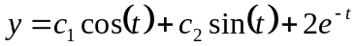 | (17)

It is found by adding the general solution of, y”+ y = 0, to the particular solution 2e^{-t}.

Method of Undetermined Coefficients:
Suppose we want to solve:
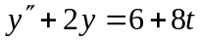 | (18)

Since the RHS is a linear function, try a linear function:
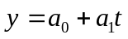 | (19)

We find that 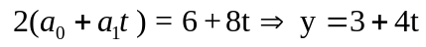 satisfies the original differential equation.
Suppose we want to solve:
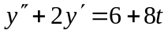 | (20)

It fails because this choice makes both y” and y’ constant.
Try:
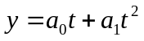 | (21)

Now:
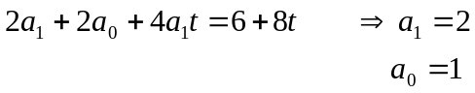 | (22)

The method also works for exponential functions:
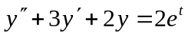 | (23)

Try:
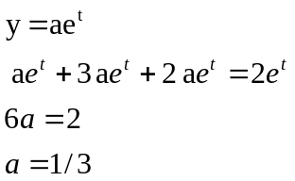 | (24)

The general solution is found by adding the complimentary solution.
The equation:
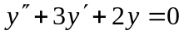 | (25)
has the characteristic equation:
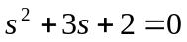 | (26)
and roots:
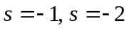 | (27)

The general solution is:
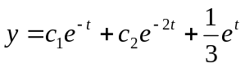 | (28)

If you try to solve:
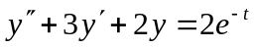 | (29)

with the trial solution 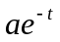 you get 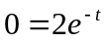

Why? Because the inhomogeneous term has the form of the complimentary solution. In this case, try 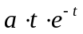. We find:
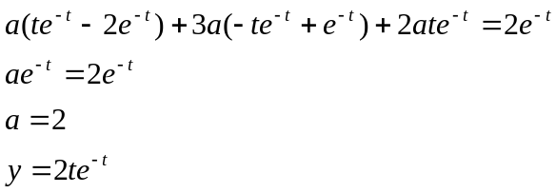 | (30)

Initial value problems are solved using the particular solution, the complimentary solution and the initial conditions to determine unknown constants.
Now try an oscillation - a complex exponential
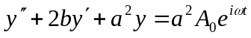 | (31)

Trial solution is 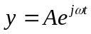
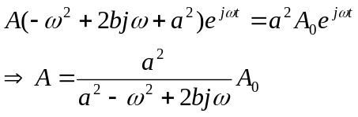 | (32)

The magnitude 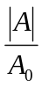 is the gain:
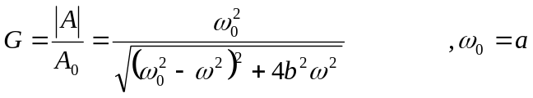 | (33)

Proof of (33):
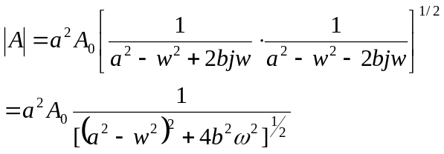 | (34)

The phase is:
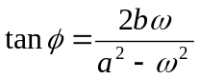 | (35)

Example (beats)
ω and ω₀ are unequal positive constants.

Solve:
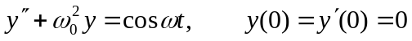 | (36)

The trial solution is:
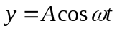  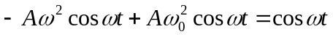 | (37)

It works, provided that:
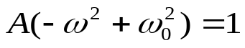 | (38)

Particular solution is then:
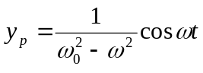 | (39)

Adding the homogeneous solution gives:
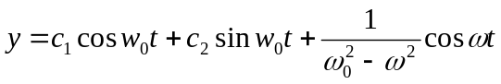 | (40)

Now apply initial conditions:
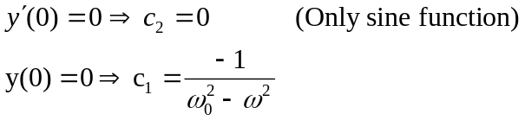 | (41)

Solution then is:
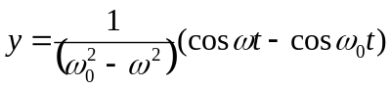 | (42)

Use:
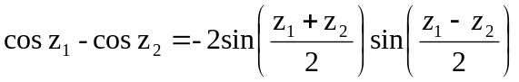  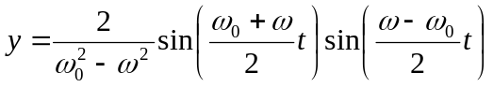 | (43)

Since ω≈ω₀, the second factor varies slowly compared to the first.
The factor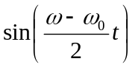 induces amplitude modulation:

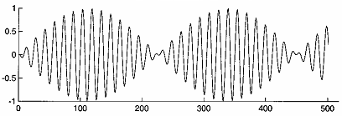

Analogies between Electrical and Mechanical Systems:
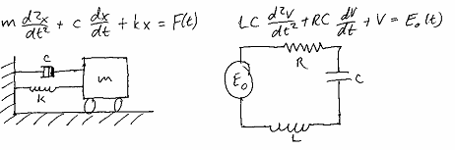

GENERAL CHARACTERISTIC | MECHANICAL PROPERTY | ELECTRICAL PROPERTY
Independent Variable | Time (t) | Time (t)
Dependent Variable | Position (x) | voltage (v) or charge (q)
Inertia | Mass (m) | LC – inductance
Resistance | Drag (c) | RC - resistance
Stiffness | Stiffness (k) | 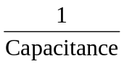
Resonant Frequency | ω₀² = k/m | ω₀² = 1/LC
Period | 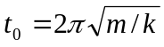 | 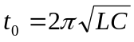
figure of merit | 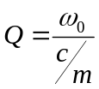 | 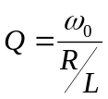

Greens Functions (Mechanics, Symon, pp 57-61)

Impulse force applied to:
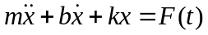
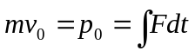 - analog exists for applied voltages in electricity
Position at instant t_{o} when impulse occurs:
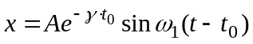
Velocity at t = t_{o} is:
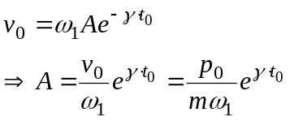
Solution is:
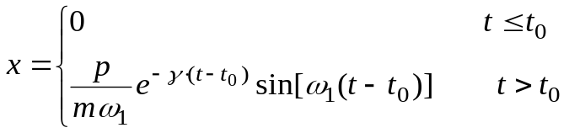
Now suppose that:
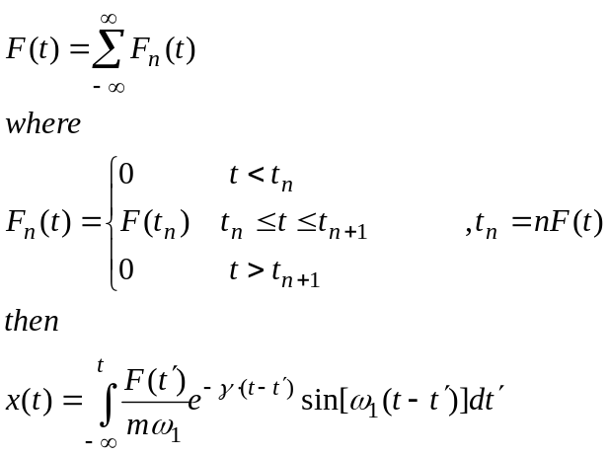
The function:
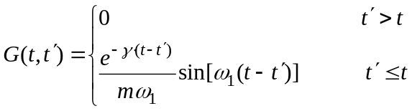
is the Greens function for
In terms of the Green’s function:
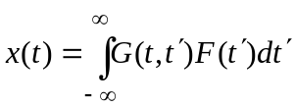

References
- Kreysig, Advanced Engineering Mathematics, Chapters 1 and 2
- IS Sokolnikoff and RM Redheffer, Mathematics of Science and Modern Engineering,
Chapter 3
- Symon, Mechanics, Section 2.11

Homework Problem

You are briefed for access to a special QRC project. US government sources have learned that a foreign paramilitary group communicates with modified HF single sideband radios operating in two modes. A key click mode radiates signals that are intended to be difficult to detect and exploit (See The Clear and Present Danger by Tom Clancy). A CW (continuous wave) mode provides interference immunity. The front end of captured radio is diagrammed below. You must develop a software patch for surveillance receivers deployed on Blackhawk helicopters monitoring the situation. The software patch will correlate a reference waveform with radio recordings tuned to the key click transmission frequency.

Key click mode

Refer to the front end block diagram attached.

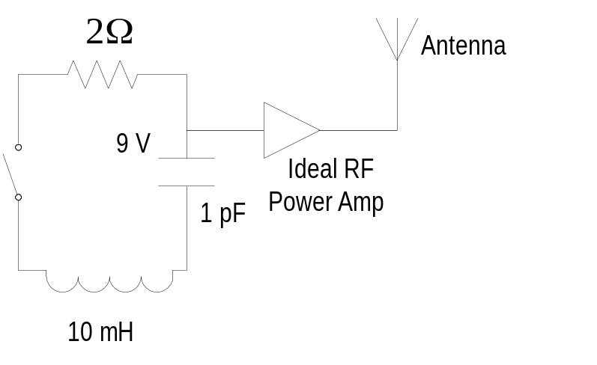

A 9V battery charges the 1pF capacitor through a charging circuit not shown. When the operator presses the transmit key, the switch closes, discharging the capacitor through the series RLC circuit. The voltage level of the capacitor is amplified and transmitted through an ideal current amplifier into the transmit antenna network. We want to calculate the key click waveform for implementation in the surveillance receiver.

a. Write the differential equation for the voltage across the capacitor
b. Find the general solution for this equation
c. Solve the unknown coefficients for the initial condition
d. Plot the equation. Experiment with different time steps for the plot. Note that unless you plot points with a frequency higher than twice the center frequency, your plot will be “aliased.” This term refers to making a high frequency sinusoid to appear to be at a lower frequency by undersampling the wave form. However, if you plot at such a high rate, you need at least a few hundred thousand points. Therefore, show the overall pulse envelope, but also explain what happens at high resolution within the pulse.
e. Identify the center frequency of the waveform
f. Identify the characteristic pulse time
g. Compare the sensitivity of a correlation detector using your software patch to a 100 ms pulse detector. Estimate how this affects the detection range of the aircraft.
Hint. Write expressions for the signal energy collected by the pulse detector and the correlation detector. Next, write expressions for the respective noise energies. Form the ratio of the two signal to noise values and find the improvement in dB. If you’re still stuck, think about whether integrating for 100 ms in the pulse detector is consistent with the pulse time you found in part f.

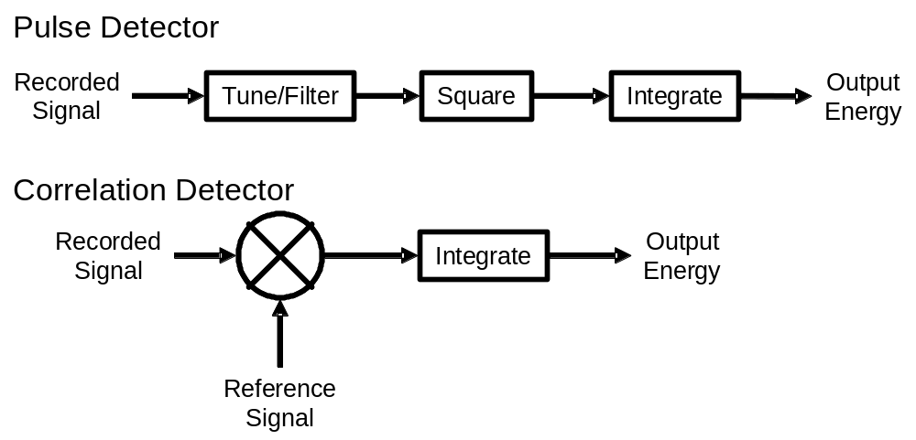

Continuous Wave (CW) mode

It may also be possible to replace the switch with an oscillator in order to operate the radio in a continuous wave instead of a pulsed mode. If this were done, determine the maximum useful tuning bandwidth of the RLC circuit. To do so, assume that the oscillator generates a voltage of the form E=E₀ exp (jωt).

- Solve the steady state differential equation for the voltage across the capacitor.
- Find the gain of the RLC network.
- Plot the gain.
- The useful bandwidth is the frequency range where the gain is within 3 dB of its maximum. Find the maximum gain, the resonant frequency and the 3 dB bandwidth.

